PART I (80 Marks)

Mark your answers to Questions 1–40 on the SEPARATE MULTIPLE CHOICE ANSWER SHEET, using a 2B, B or HB pencil. If you make an error, follow the instructions given to you on the answer sheet.

SELECT THE SINGLE CORRECT ALTERNATIVE IN EACH OF THE FOLLOWING QUESTIONS

1. Consider the following diagram of skulls.

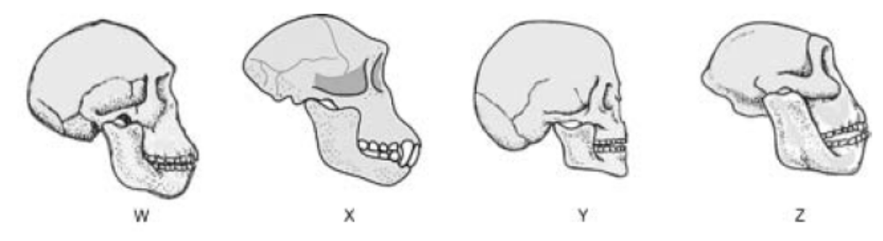

The skull most likely to be that of a chimpanzee is:

- W.
- X.
- Y.
- Z.

2. In modern times the movement of people around the world has increased. This has altered the course of human evolution by increasing

- gene flow.
- mutations.
- genetic drift.
- geographical isolation.

3. A person with the inherited condition of ptosis is not able to lift one or both upper eyelids to uncover the eye completely. A family tree showing the incidence of ptosis is given below.

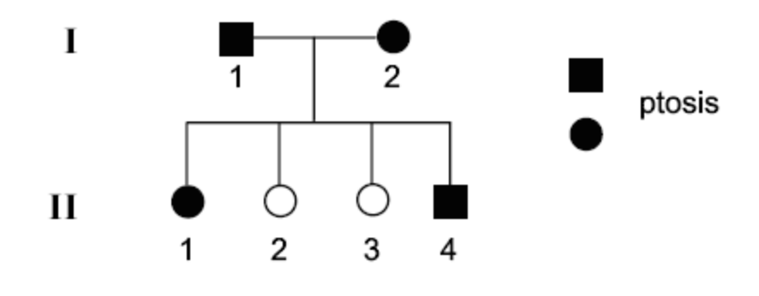
What is the most likely mode of inheritance for ptosis?

- Autosomal recessive
- Autosomal dominant
- Sex-linked recessive
- Sex-linked dominant

4. Which of the following is the correct order of cultural development associated with the hominid ancestors of modern humans?

- Oldowan, Acheulian, Mousterian
- Oldowan, Mousterian, Acheulian
- Acheulian, Mousterian, Oldowan
- Acheulian, Oldowan, Mousterian

5. Evidence for hominid cultural evolution would include

- position of the attachment of the spine to the head.
- length of arm bones in comparison to leg bones.
- number of teeth present in the skull.
- presence of stone tools.

6. Evidence for evolution includes data from comparative anatomy and embryology. When comparing two species such evidence would be obtained from

- chromosome numbers.
- mitochondrial DNA.
- shared habitats.
- the presence of gill slits during development.

7. The diagram below shows the possible evolutionary relationships between chimpanzees and the genera of humans.

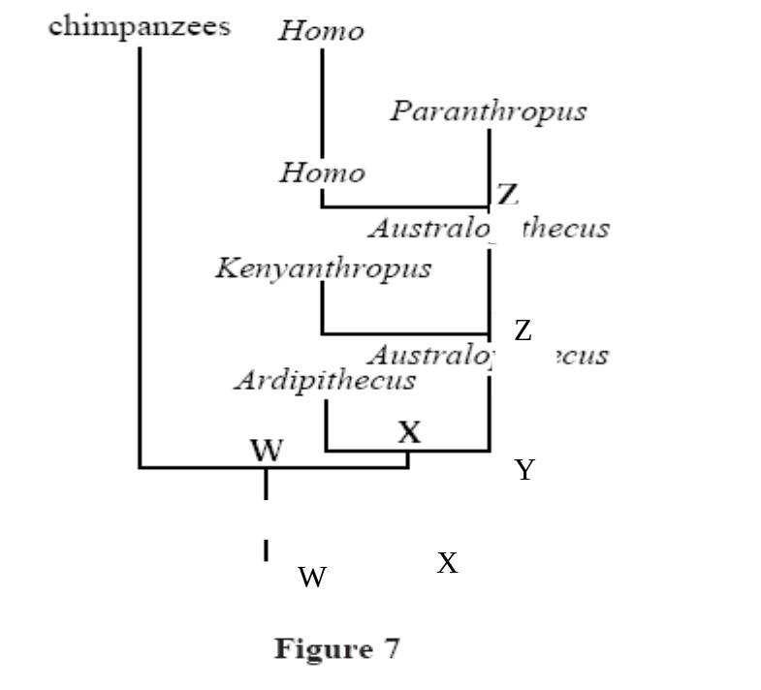

The most recent common ancestor of Homo and Kenyanthropus is represented on the diagram at

- Z.
- Y.
- X.
- W.

8. Achondroplasia is an autosomal dominant trait in humans that results in a form of dwarfism. In some cases a child with achondroplasia is born to parents who have normal height.

The most likely reason for the appearance of the child with achondroplasia is that:

- the parents are carriers and the child has inherited the mutant allele from each parent.
- a mutation has occurred in a gamete of either the mother or the father.
- a mutation has occurred in one of the somatic cells of one of the parents.
- a mutation has occurred in the tissues of the child.

9. Which of the following statements is TRUE?

- Greenhouse gases cause the breakdown of the ozone layer.
- Burning coal and petroleum products cause an increase in greenhouse gases.
- The breakdown of the ozone layer causes global warming.
- Global warming is caused by the accumulation of chlorofluorocarbons in the atmosphere.

10. The group of primates that includes monkeys, apes and humans is known as the

- anthropoids.
- australopithecines.
- hominids.
- hominoids.

11. When single stranded DNA from a human is mixed with a single-stranded DNA from a chimpanzee, we find that about 99% of the DNA is homologous. This is taken as evidence that

- humans and chimpanzees originated in similar environments.
- humans evolved from chimpanzees.
- chimpanzees evolved from humans.
- humans and chimpanzees are closely related.

12. Natural selection acts directly on

- the phenotype of an individual.
- the genotype of an individual.
- the entire genome.
- the population gene pool.

13. Darwin’s concept of Natural Selection is closest in meaning to which of the following statements?

- In any population variation exists and much of this variation is heritable.
- Individuals with more favourable traits are more likely to reproduce and these inherited favourable traits become more common in succeeding generations.
- Individuals in a species naturally select the habitat and niche to which they are best suited.
- Similar individuals will mate to produce offspring with more favourable traits increasing heir survival

14. The first hominid species known to have made tools was Homo

- sapiens.
- afarensis.
- habilis.
- erectus.

15. As the human ancestors diverged from other primates, which of the following appeared first?

- Toolmaking
- Language
- An erect stance
- Large brain

16. Hominid fossils have been found in rocks near the surface at three different sites in the Olduvai Gorge in Africa. The diagram is a cross-section of the rocks which underlie the area of the fossil finds.

Y Z

X
Sandstone

Shales

Coal

Which of these fossils would be significantly older than the others?

- X
- Y
- Z
- All are the same age as they are on the surface.

17. Which of the following karyotypes is most likely to be found in a normal human sperm?

- 22, X
- 23, Y
- 46, Y
- 46, XY

18. Skin colour is controlled by at least 3 separately inherited genes with ‘dark-skin’ incompletely dominant to ‘light-skin’. The alleles have an additive effect. Genotype AaBbCc produces the same skin colour as AABbcc because they both have three dominant alleles. The Hodgson’s twins were born to a mother with AaBBcc genotype and a father of AaBbCc genotype.

Twin A on the left has the same skin colour as her parents. Twin B on the right has light skin.

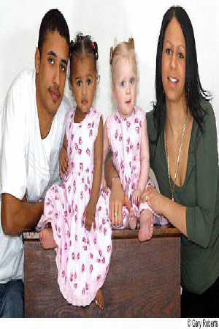

What are the possible genotypes of the twins?

 | Twin A | Twin B
(a) | AABBCC | aabbcc
(b) | AABBcc | AabbCC
(c) | Aabbcc | AABbCC
(d) | AABbcc | aaBbcc

19. Red-green colour blindness is sex-linked affecting about 8% of males and 0.5% of females. The possible combinations of sex and colour blindness in the children of a normal male and a carrier female could be represented as follows:

- 2 normal females; 2 normal males.
- 2 normal females; 1 normal male; 1 colour blind male.
- 2 normal females; 2 colour blind males.
- 1 normal female; 1 colour blind female; 1 normal male; 1 colour blind male.

20. Compared to an industrial society, a hunter-gather society will most likely

- require more specialisation in of labour.
- will have less energy requirements.
- will have greater impact on the environment.
- will consume greater resources per person.

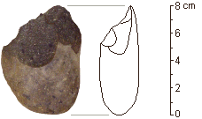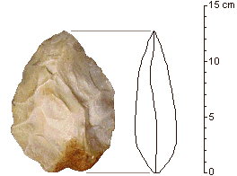
Tool A Tool B

21. Which of the following statements is correct for the tools shown above?

- Tool A was produced by Homo habilis and is older than Tool B which was made by Homo erectus.
- Tool A was used by women because it is smaller than Tool B which was used by men.
- Tool A is more finely worked than Tool B and was often attached to pieces of wood to form stone axes.
- Tools A and B are made from the flakes chipped from the core of stone.

22. Calcium is an important mineral requirement of the body. It is important in the structure of bones and in muscle movement. Calcium blood levels are controlled by

- thyroid glands producing thyroxine.
- parathyroid gland producing parathormone.
- hypothalamus producing testosterone.
- pituitary gland producing prolactin.

23. Which of the following separates the outer ear from the middle ear?

- Cochlea
- Three ear bones
- Eardrum
- Eustachian tube

24. Which of the following drugs has recently been linked to an increase incidence of schizophrenia in long term users?

- Alcohol
- Cannabis
- Heroin
- Nicotine

25. A student set up an experiment with a semi-permeable membrane. The membrane was not permeable to sucrose. At the beginning of the experiment the same amount of water was added to both sides of the membrane. The student then added sucrose to the left side of the membrane as shown in the following diagram.

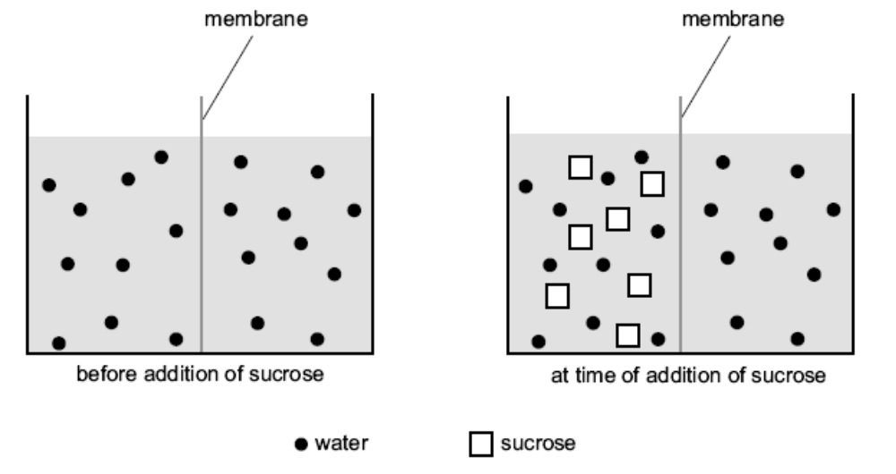
You would expect

- the level of water to rise on the left of the membrane.
- the level of water to rise on the right of the membrane.
- the level of water to remain unchanged on both sides of the membrane.
- the concentration of sucrose to increase on the right side of the membrane.

26. The advantage of a naturally acquired active immunity is that it

- is long lasting, sometimes for life.
- can develop without exposure to antigen.
- produces antibodies against a range of infective agents.
- provides antibodies immediately the first time one is exposed to a particular bacterium.

27. The measles (rubella) virus causes a highly infectious childhood disease involving nasal discharge, cough and fever.

It is reasonable to assume that

- an antibiotic would be effective in curing measles.
- no vaccine against measles is available.
- the virus is eliminated by the action of antibodies and T lymphocytes.
- the disease is highly infectious because the virus replicates on children’s toys or play equipment.

28. When using a light microscope, the magnification of the cells being observed can be changed by altering the

- light intensity.
- objective lens used.
- coarse focus.
- position of the stage.

29. Macrophages are large white blood cells that:

- divide to produce B lymphocytes.
- engulf bacteria and destroy them.
- produce antibodies against specific antigens.
- secrete bacterial-destroying enzymes into the blood.

30. Which of the following is NOT a function of the cerebrospinal fluid?

- Protection of the central nervous system from mechanical damage.
- Aid removal of metabolic wastes and supply of nutrients to nerve tissue.
- Suspension of the brain in fluid to reduce pressure on particular points.
- To transfer neural messages from one part of the brain to another.

31. When a neutrophil (a type of white blood cell) encounters a bacterium, it sends out projections of its plasma membrane that surround the bacterium. The two sides of the plasma membrane then fuse together forming vesicle, which contains the bacterium, inside the cell. This is an example of

- pinocytosis.
- exocytosis.
- transcytosis.
- phagocytosis.

32. Put the following parts of a reflex arc in the correct order, beginning with the sensory receptor.

1. motor neuron
2. interneuron
3. effector
4. sensory neuron
5. sensory receptor

(a) 5, 1, 2, 3, 4
(b) 5, 3, 2, 4, 1
(c) 5, 4, 3, 2, 1
(d) 5, 4, 2, 1, 3
The next two questions refer to the following diagram of the regulation of carbon dioxide concentration in arterial blood.

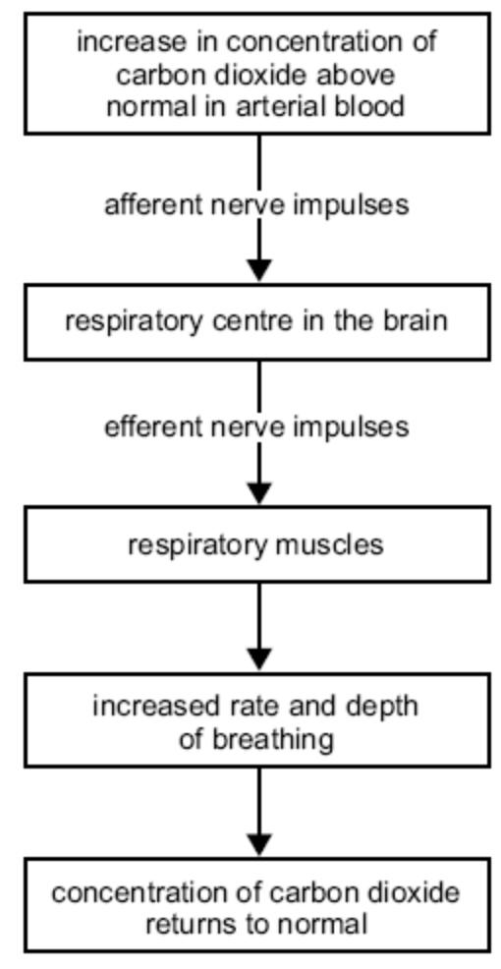

33. The effector in the regulation of carbon dioxide concentration is the

- respiratory muscles.
- efferent nerve impulses.
- respiratory centre in brain.
- afferent nerve impulses.

34. When the concentration of carbon dioxide returns to normal it would be reasonable to conclude that the

- respiratory muscles stop contracting.
- rate and depth of breathing decrease.
- number of afferent nerve impulses increase.
- respiratory centre in the brain fails to send efferent nerve impulses.

35. Glycogen is best described as a

- carbohydrate that is often stored in red blood cells.
- complete protein necessary for the synthesis of cell membranes.
- complex carbohydrate that is synthesized and stored within the human liver.
- by-product of glucose digestion within the pancreas.

36. Which of the following is a function of oestrogen?

- To start menstruation
- To stimulate the posterior pituitary
- To cause maturation of the corpus luteum
- To start the growth of the endometrium

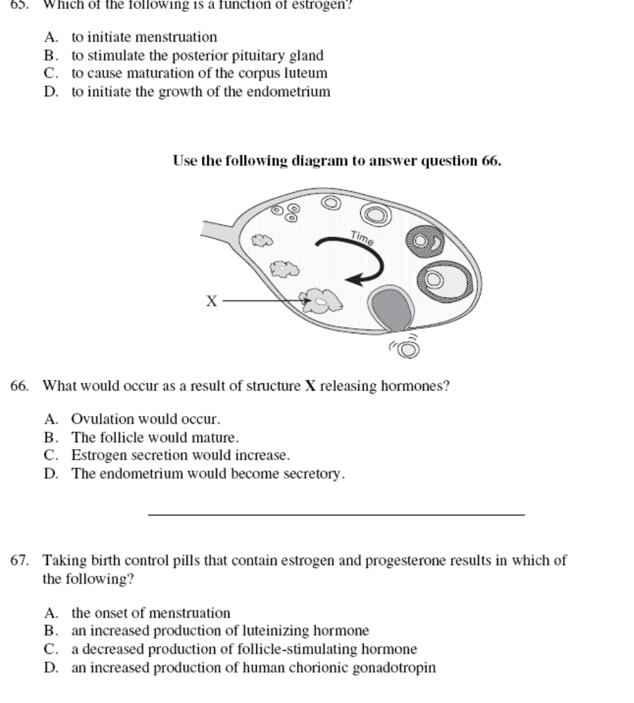

37. The diagram above shows the ovarian cycle. What occurs as a result of Structure X releasing hormones?

- Ovulation
- Maturation of the follicle
- Increased secretion of oestrogen
- The endometrium becomes secretory

38. The autonomic nervous system includes

- the brain and spinal cord.
- the sensory and motor nerves.
- the cerebellum and cerebrum.
- the sympathetic and parasympathetic nervous systems.

Consider the following equation that is the summary of an important biochemical process occurring in all cells.

C₆H₁₂O₆ + O₂ → 6H₂O + X + energy

39. The product X in this reaction is

- sugar.
- carbon dioxide.
- monosaccharide.
- amino acid.

40. In an experiment to test the performance of year 12 human biology students, which of the following is the dependent variable?

  - Sex
  - Test scores
  - School type
  - Postcode

Question | Answer | Question | Answer
1 | b | 21 | a
2 | a | 22 | b
3 | b | 23 | c
4 | a | 24 | b
5 | d | 25 | a
6 | d | 26 | a
7 | b | 27 | c
8 | b | 28 | b
9 | b | 29 | b
10 | a | 30 | d
11 | d | 31 | d
12 | a | 32 | d
13 | b | 33 | a
14 | c | 34 | b
15 | c | 35 | c
16 | c | 36 | d
17 | a | 37 | d
18 | d | 38 | d
19 | b | 39 | b
20 | b | 40 | b

PART II (80 Marks)

Write answers to ALL questions on the ruled lines after each question or in the spaces provided within each table. Write your answers in blue or black ballpoint or ink pen.

Question 41 (Total 9 marks)

In 1912, an ancient skull was found in a limestone quarry in England. It was named Piltdown Man after the small town nearby. It was thought to be the “missing link” between apes and humans. The Piltdown Man skull was declared a forgery forty years after it had been discovered. It had been put together using a recent orang-utan jaw, chimpanzee teeth and the cranium of a medieval human. These had all been cleverly altered to fit together.

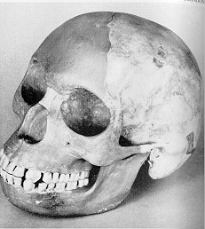
Figure 1: Piltdown Man skull

- What two features of the skull would have been used to classify it as ‘human’?
(2 marks)

Any two of the following (1 mark each)
  - high forehead
  - large cranium
  - flattened face/facial angle
  - size of zygomatic arch
  - lack of browridges
  - no evidence of sagital crest
  - reduced size of canines

- The forgery was not discovered for forty years. Explain one technique of fossil dating which would expose the skull as a forgery.
(2 marks)

Any one of the following named (1 mark each) explained (2 marks)
  - radio carbon dating - would show differences in ages of bones; skull older than jaw, so could not have been from the one organisms
  - DNA profiling - if DNA could be extracted from different bones it would give different bands/peaks on the profile indicating different organisms
  - protein analysis - as for DNA profiles
  - scanning electron microscopy - would show the alterations to the surfaces of the bones and teeth indicating that they had been modified and not natural

Figure 2 below shows the profile of an archaeological excavation.

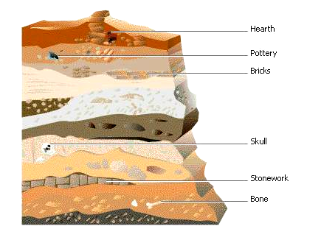

c. Artefacts and fossils were found at this site.
What is an artefact and give an example of an artefact from this profile.
(2 marks)

  - artefact - eg. pottery, bricks, stonework, hearth
    - an object produced or shaped by human craft
    - an object used, modified or made by humans
    - something created by humans usually for a practical purpose

d. Explain the difference between relative dating and absolute dating of fossils?
(3 marks)

Any 3 of the following:
  - relative dating -
    - no specific time age given
    - age comparative to another item
  - absolute
    - age in years is given
    - no other item required for comparison

Question 42 (Total 12 marks)

Retinitis pigmentosa is a genetic condition in which the most common form causes problems with night vision and peripheral vision. Peripheral vision is gradually lost, but complete blindness is uncommon.

Figure 3: Cross section of the human eye

A
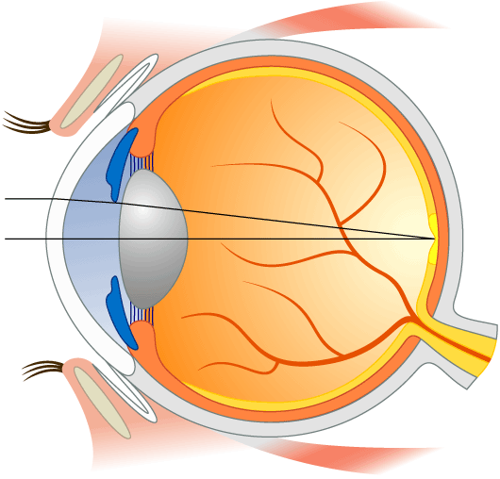
B

C

D

a. Label the parts of the eye indicated in the Figure 3.

A. sclera, scleroid layer
B. choroid, choroid layer
C. retina
D. lens

b. Which of the light-sensitive receptors is affected by retinitis pigmentosa? In what part of the retina are they mainly located?
(2 mark)

Rods Peripheral part of the retina / outside the fovea/macula
c. Name and describe a vision impairment caused by a defect in structure D in the diagram.
(2 marks)

Any one of the following (1 mark for name; 1 mark for vision impairment))
  - cataracts - loss of transparency of the lens/cloudiness in lens causing blurry vision
  - astigmatism - irregular surface shape of lens causing distorted images on retina
  - presbyopia - loss of elasticity of lens causing reduced accommodation abilities of lens - near point further away from eyes.

Researchers have identified the gene that controls the production of the light-sensitive pigment, rhodopsin, found in the light receptors in the eye. About 50 different mutations have been found in this gene in people with retinitis pigmentosa.

d. Explain how so many different mutations can cause the one condition of retinitis pigmentosa.
(2 marks)

Any two of the following (1 mark for each)
  - gene is a long sequence of bases
  - mutations can occur in different parts of the gene
  - sequence is changed to disrupt protein produced

e. Retinitis pigmentosa is an example of a condition caused by a gene mutation. Chromosome mutations can also occur.
Name a chromosome mutation, and describe the condition it causes.
(2 marks)
________________________________________________________________________

________________________________________________________________________

________________________________________________________________________

One mark for the name of a chromosome mutation (Downs, Turners, Klienfelters etc)
One mark for some correct information about the condition (mental retardation, short stature - normal intellect – infertile, phenotypic male but with breast development etc )

Question 43 (Total 6 marks)

Figure 4: Table of statistics comparing Australia and Ethiopia.

Statistics | Australia | Ethiopia
population current | 20.78 million | 75 million
population 2015 (predicted) | 24 million | 104 - 115 million
population growth rate | r | 22.72/1000
Birth rate | 12.02/1000 | 37.39/1000
Infant mortality rate | 4.57/1000 live births | 91.9/1000 live births
Death rate  (overall population) | 7.56/1000 | 14.67/1000
Fertility rate (average number of children born per mother) | 1.76 | 5.1
Net migration rate  [immigration (entering) - emigration (leaving) = net migration rate] | 3.78/1000  (more people immigrate than emigrate) | 0/1000  note: repatriation of Ethiopian refugees residing in Sudan is expected to continue; some Sudanese, Somali, and Eritrean refugees, who fled to Ethiopia from the fighting or famine in their own countries, continue to return to their homes giving an overall net migration rate of zero

a. Calculate the population growth rate (r) for Australia from the information given in the table above. (Show your working.)
(2 marks)

r = (birth - death) + (immigration - emigration)
= (12.02/1000 - 7.56/1000) + 3.78/1000 (1 mark)
= 8.24/1000
Australia has a growth rate of 8.24/1000 (1 mark)
b. Suggest two possible reasons for the difference in infant mortality rates between Australia and Ethiopia.
(2 marks)
Any two of the following (1 mark for each)
  - Australia has
    - better health system to treat infantile diseases
    - vaccinations against infant diseases
    - better hygiene/sanitation systems to reduce spread of disease
    - good food supplies to promote healthy growth
    - clean water supplies to reduce incidence of water borne disease

Figure 5 shows two demographic profiles of countries at different stages of development.

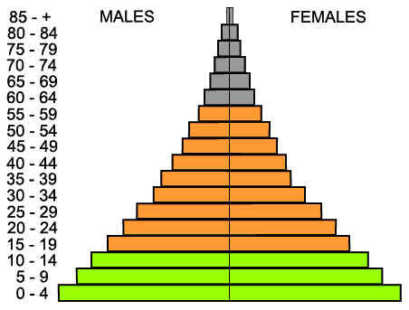
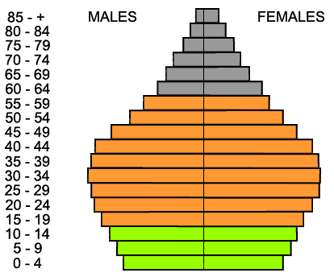
Profile A Profile B

c. Which profile represents the situation in Ethiopia? Explain your choice.
(2 marks)

Profile A - Ethiopia (1 mark)
Any three of the following (1 mark for each)
  - large birth rate
  - high infant mortality rate
  - low average life span

Question 44 (Total 7 marks)

Thalassaemia is the name given to the rare inherited condition due to an abnormality in the production or structure of an important protein in the blood, called haemoglobin. It is caused by a single gene mutation.

Figure 6: Part of a family tree showing the inheritance of thalassaemia.

I
1 2 3 4

II
1 2 3 4 5 6 7 8

III

1 2 3 4 5

a. State the type of inheritance pattern shown in this family. Explain your answer using evidence from the family tree.
(2 marks)
Autosomal recessive (1 mark)
Any one of the following (1 mark for each)
  - two unaffected parents (II 3 and II 4) produce affected offspring (III 2, III 3)
  - unaffected father produces affected daughter and affected son ( not sex-linked)

b. II 4’s family had never had any incidence of the disorder in his family. Explain how he could have fathered two children with the disorder.
(2 marks)

Any two of the following (1 mark for each)
  - recessive allele could be present in father’s family
  - does not show until combined with another recessive
  - any one in the family who had the condition died before it was recognised
  - father would have to have the recessive allele in his genotype
  - the condition is too rare to have two sperm in one person mutate to produce two affected offspring
  - mutation occurred in one of II 4’s parents/grandparents for it to be in II 4’s genotype

c. Explain the possible genotypes, and the probability of each, of III 1.
(3 marks)

Two marks for the explanation and working, 1 mark for the correct probablility
T - normal t - thalassaemia
II 3 (Tt) x II 4 (Tt) (1 mark)

 | T | t
T | TT | Tt
t | Tt | tt
(1 mark)
III 1 is NOT tt.
III 1 can only be TT or Tt (1 mark)

Probability: 1/3 TT or 2/3 Tt (1 mark) (must have this point to get 3 marks)

Question 45 (Total 10 marks)

Diabetes is a condition in which the pancreas fails to produce one of the two hormones involved in glucose control. A glucose tolerance test was carried out on a healthy person and a person with diabetes. In this test, 75 g of glucose is given to a person who has not eaten since the night before. The level of glucose in the blood is then tested for the next three hours.

Figure 7: Blood glucose concentrations during a glucose tolerance test for two different people.

 | Glucose Concentration in Blood (mg/100 mL)
Time after glucose ingestion (mins) | Person A | Person B
0 | 75 | 75
30 | 125 | 125
60 | 110 | 130
90 | 90 | 135
120 | 80 | 140
180 | 70 | 140

a. Present this information as a graph on the grid provided below. (5 marks)

b. Which person has diabetes?
(1 mark)

Person B

Explain your choice.
(2 mark)
Any two of the following:
- The level of glucose in the blood continues to rise for the three hours
- Sugar levels should have decreased back towards initial levels as shown in Person A

c. After 30 minutes in a healthy person, the pancreas increases the rate of production of which hormone involved in glucose control?
(1 mark)

Insulin

What is the action of this hormone on body cells?
(1 marks)

Accelerates (any one of the following)
- the transport of glucose from the blood into the cells
- conversion of glucose to glycogen
- decreases glycogenolysis
- slows down gluconeogenesis

Question 46 (Total 9 marks)

Figure 8: Flow diagram showing how the body uses amino acids.

Proteins in food
Process A
amino acids

excess amino acids
body cells

Process B

glucose
urea

Urine
kidney

a. What is the name of Process B?
(1 mark)

deamination

b. In which organ are excess amino acids converted into urea?
(1 mark)
liver

Figure 9: The human urinary system.
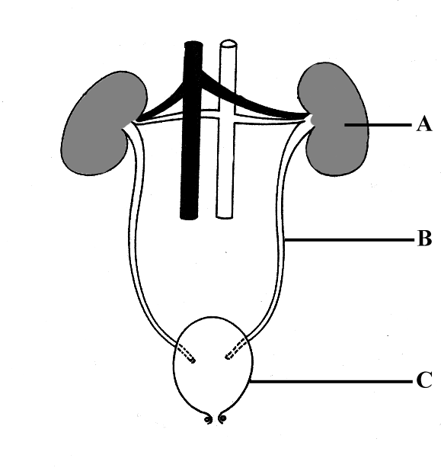
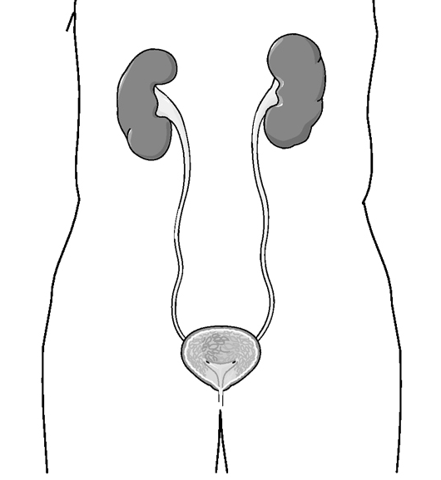

A

B

C

c. Name the parts labelled A and B.
(2 marks)

A. Kidney

B. Ureter

d. What is the function of the part labelled C?
(1 mark)

stores urine until it is convenient to release it

e. Name two substances other than urea that are excreted by the kidneys.
(2 marks)

Any two of the following:
- water
- salts
- creatinine
- hormones
- enzymes
- inorganic ions
- drugs and penicillin

Figure 10: Graph of the level of anti-diuretic hormone (ADH) in the blood and the rate at which urine is formed
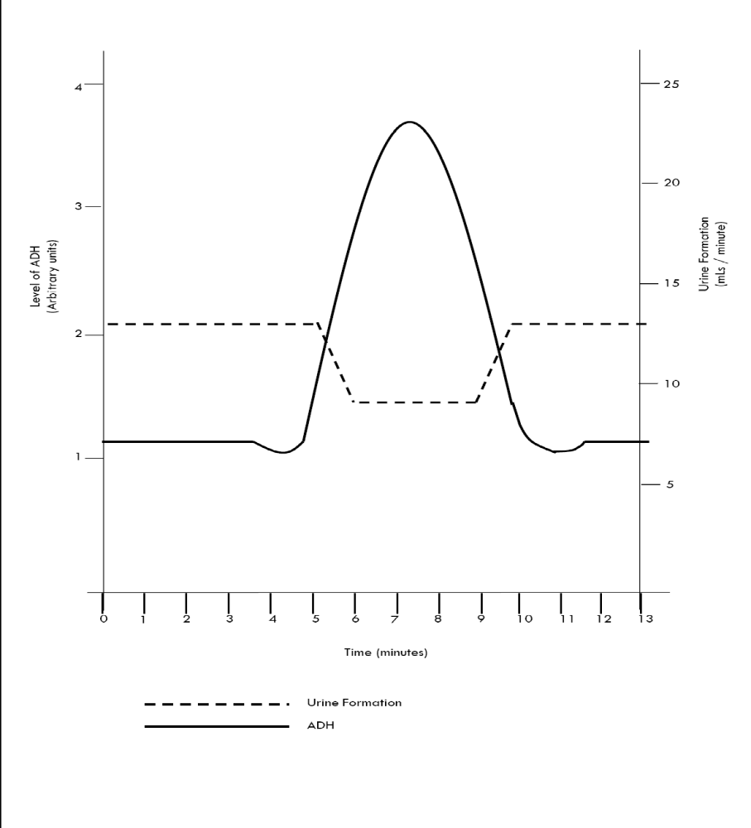

f. What is the normal rate of urine production?
(1 mark)

2.5 cm³ / minutes (must have both number and units)

g. What effect does a fall in the level of ADH have on the rate of urine production?
(1 mark)

decreased levels of ADH increase the rate of urine production

Question 47 (Total 6 marks)

Figure 11: Graph of the levels of measles antibodies in a child from birth to 7 years of age.
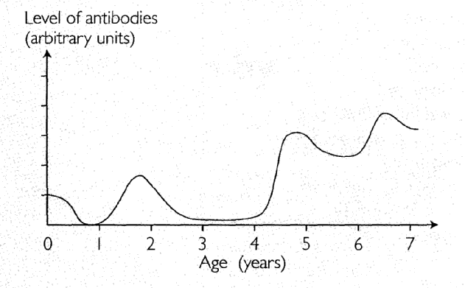

a. The child has antibodies against measles at birth. What is the source of the antibodies?
(1 mark)

mother across the placenta

b. The antibody levels drop to zero very quickly after the age of about 6 months.
Suggest some reasons why this may occur.
(2 marks)

Any two of the following:
- child stopped breast feeding at 6 months
- antibodies are broken down and removed from the body
- no other source of antibodies in food intake
- child can’t produce them as there is no immune response

c. The child was immunised against measles at 1 year old and again at 4 years old.
What cells are stimulated to produce antibodies after the first immunisation injection?
(1 mark)

B lymphocytes

d. At 6 years of age, production of antibodies increases dramatically, but no vaccination has been given. Explain a possible reason why.
(2 marks)

- child came in contact with another source of the virus eg another child who had the disease
- antibodies are only formed in the presence of the antigen (measles virus)

Question 48 (Total 8 marks)

Figure 12: Diagram of two nerve cells.

Inset circle size:
Diameter = 6cm
Area = 30cm²

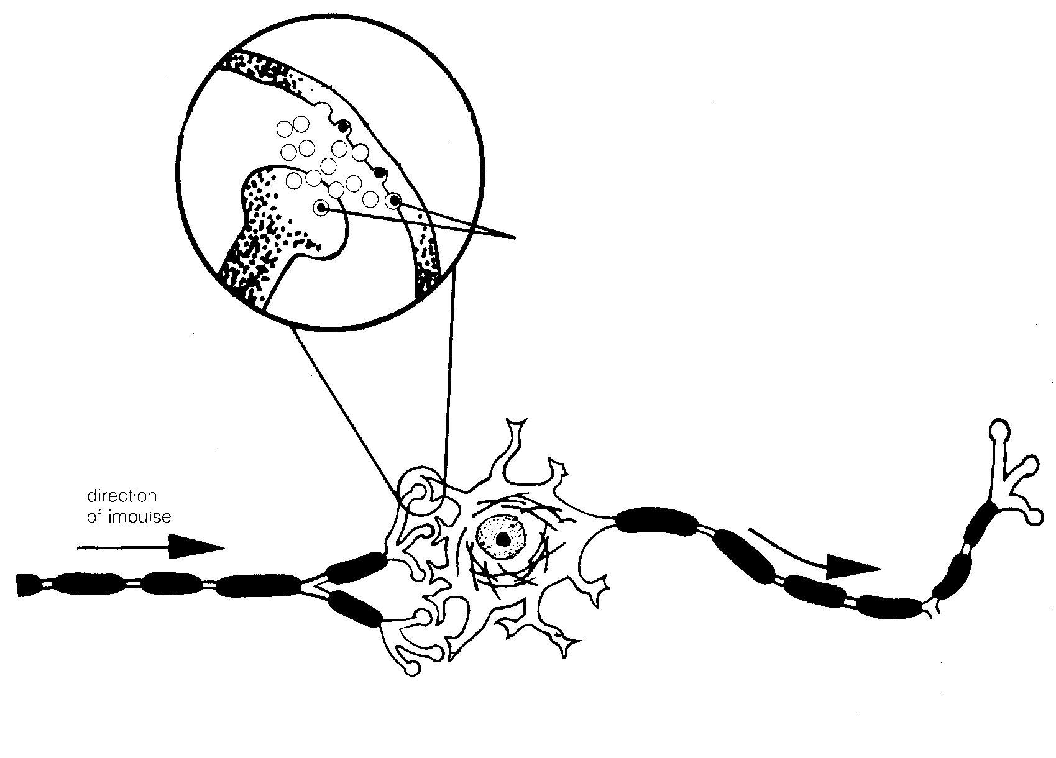
Small circle size:
Diameter = 0.6cm
Area = 0.3cm²
A

E

D

C

B

a. Name the structures indicated in Figure 12.
(4 marks)

A. cell body of neuron/nerve cell

B. dendrite

C. synapse

b. Structure D is the myelin sheath. What is the function of structure D?
(1 mark)

insulates the axon electrically from other nerve fibres
increases the speed of nerve transmission
c. Name ONE chemical that serves the function of E.
(1 mark)

acetylcholine
noradrenaline
dopamine
serotonin

d. Calculate the magnification represented by the inset circle compared to the main figure (small circle) Show your working.
(3 marks)

10x

Size of small circle = 0.6 cm
Size of inset circle = 6.0 cm

Magnification = 6.0/0.6 = 10x

Question 49 (Total 13 marks)

Figure 13: Human brain from inferior view.

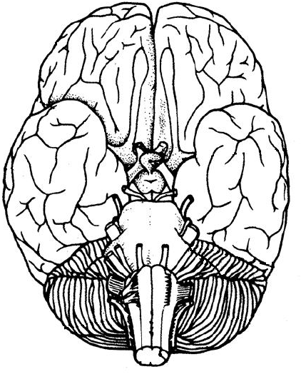
C
B
A

a. Fill in the following table with reference to the labels in Figure 13.
(4 marks)

Label | Name of part | Function of part
A | cerebellum  (1 mark) | controls skeletal muscle contractions for co-ordination of skilled movements, posture and balance (1 mark for any one of the above)
B | medulla oblongata  (1 mark) | regulation of vital body functions through the (1 mark for any of the following)  - cardiovascular centre - regulates rate and force of heart beat and diameter of blood vessels  - respiratory centre - adjusts breathing rhythm  - other centres co-ordinate swallowing, vomiting coughing, sneezing and hiccupping

The section of the brain outlined in the box labelled C in Figure 13 is shown below in sagittal section.

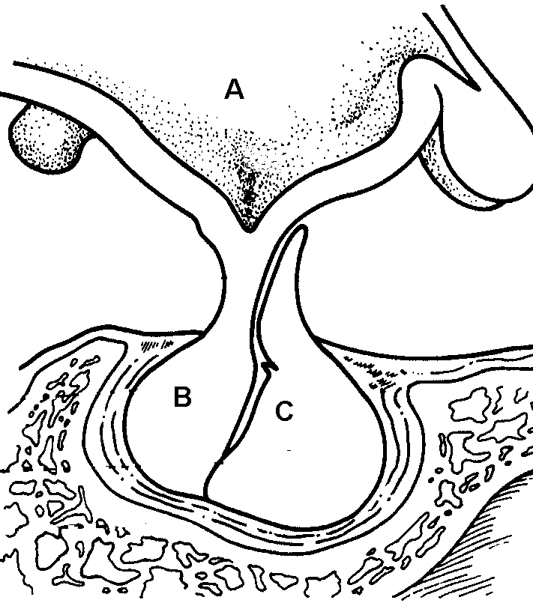
front of brain →

b. Identify the structures labelled.
(2 marks)
A. hypothalamus
C. anterior pituitary

c. Where are the hormones secreted from B produced?
(1 mark)
in the hypothalamus

d. Complete the following table for any two hormones produced at C.
(4 marks)

Hormones produced by C | Target organ
human growth hormone (hGH) | stimulates general body growth and regulates aspects of metabolism
adrenocorticotropic hormone (ACTH) | adrenal cortex
prolactin | mammary glands
thyroid stimulating hormone (TSH) | thyroid
follicle stimulating hormone (FSH) | ovaries  testes
luteinising hormone (LH) | ovarian follicle (ovulation)  formation of corpus luteum  testes (secretion of testosterone)

e. Hormones from B and C travel to all parts of the body via the blood.
How does a hormone affect specific target cells and not other types of cells?
(2 marks)
hormones bind to and activate their specific receptors in cells to (1 mark) and any of the following for 1 mark
- change the permeability of the cell membrane
- alter gene expression (promoting synthesis of enzymes/other hormones)
- act as enzymes to alter the rate of specific cellular reactions
PART III (40 MARKS)

Answer ONE question from SECTION A and ONE question from SECTION B. Illustrate your answers with diagrams where appropriate. Up to TWO MARKS may be deducted for poorly structured answers: that is, answers in point form or diagrams not explained in the text of your answers. DO NOT WRITE ANSWERS IN PENCIL. Write your answers on the lined pages in your Question/Answer Booklet following the end of the questions.

SECTION A

ANSWER EITHER QUESTION 50 OR QUESTION 51 – NOT BOTH

QUESTION 50 (Total 20 marks)

On a hot day you spend several hours working or playing sport and you notice that your skin becomes red and your clothes become wet with sweat. You feel thirsty and have several large drinks of water. When you get home you notice that your urine is darker than usual and you recall with some surprise that you hadn’t felt the need to empty your bladder since you left home in the morning.

Outline the way in which these observations can be related to the physiological process of homeostasis.
(a) the sweating
(b) the thirst
(c) the low volume of strong urine produced
(20 marks)

Answer:
- Temperature regulation:
  - Body temperature increase due to
    - Hot day.
    - Metabolic heat production.
  - Detected by:
    - Thermoreceptors
    - Hypothalamus
    - Autonomic nervous system
  - Body cooled by:
    - Vasodilation – brings blood near the surface; increased heat loss by convection
    - Sweating – cools the skin by evaporation
- The thirst – regulation of body fluids
  - Osmotic pressure of the blood is reduced by:
    - Water loss from the extracellular fluid / plasma
      - Sweating
      - Evaporation
  - Detected by:
    - Osmoreceptors in hypothalamus
  - Thirst is stimulated by:
    - Nerve impulses to the thirst centre in the hypothalamus
    - Drinking behaviour activated.
- The low volume of strong urine
  - Osmotic pressure of the blood reduced (as above)
  - Detected by osmoreceptors (as above)
  - Further water loss is restricted by
    - Nerve impulses from the hypothalamus
    - To the posterior pituitary
      - ADH produced and released into the bloodstream.
    - ADH acts on the kidney
      - Distal convoluted tubules permeability increases.
      - More water is returned to the bloodstream
      - Less water enters the urine – causing a low volume of strong urine.

OR

QUESTION 51 (Total 20 marks)

(a) Fiona, a very excitable young girl, was walking along a busy street talking intensely on her mobile phone to her best friend. She was so focused on her conversation that, without thinking, she stepped onto the road and was immediately startled by the screeching of tyres and the blaring sound of a very loud horn. When she realised that she had stepped in front of a car but had not been run over, she felt greatly relieved but noticed that her body had responded in several different ways.

(i) Identify the responses that Fiona’s body would automatically demonstrate in her reaction to danger and explain how each is useful in this situation.
(6 marks)

(ii) Compare and contrast the actions of nerves and hormones in the control of body responses.
(4 marks)

Answer:
(a)
Fiona’s response to the loud noises was mediated by the “Fight or Flight” reaction through the sympathetic nervous system. (1 mark)
The release of the neurotransmitter noradrenaline by sympathetic nerve endings at the heart caused her accelerated heartbeat. (1 mark)

Any of the following: (4 marks)
- increased blood pressure and
- increased cardiac output - increase supply of blood to muscles in case movement is necessary
- increased blood volume to brain - supply increased nutrients to improve perception and response by brain
- increased blood distribution to skeletal muscles - increase supply of nutrients to allow for quick movements
- decreased blood distribution to the digestive system, kidneys, reproductive organs and skin - reduction of blood flow to areas that are not used in flight or fight
- dilated pupils - improved peripheral vision to see what is coming/happening
- dilation of airways in the lungs - improved flow of air into and out of lungs to improve supply and removal of gases
- activation of sweat glands in the skin -
- increased metabolisation of lipids from fat cells and glucose from the liver - to increase availability of energy
- release of endorphins (natural pain killers) in the brain - fight or flee even when injured

(b)
Compare action of nerves and hormones (1 mark)
- both in response to stimulus
- each has specific target organ(s)

Contrast (3 marks)
Nerves | Hormones
electro-chemical impulse | chemical messenger
discreet pathways (nerves) to target organ | general pathway to target organ (via blood stream)
rapid response time | usually slower response time
short duration of effect | long duration of effect
localised effect - each neurone links with only one or a few cells | more general effect - can influence cells in may different parts of the body
size of signal determined by number of nerve fibres stimulated or frequency of nerve impulses | size of response determined by concentration of hormone
some can be modified by learning from previous experience | cannot be modified by learning

(b) For several years, Darren has avoided all physical exercise, preferring to spend all his spare time in front of his computer and TV. One day, quite impulsively, Darren decided to take the family dog for a leisurely walk. The large, muscular dog had other ideas and turned a slow walk into a race for over thirty minutes, leaving Darren exhausted, breathing deeply and rapidly and with a very high heart rate.

With reference to the homeostatic mechanisms involved, explain why Darren’s breathing rate and cardiac output would change during this strenuous exercise and why these changes would continue for quite a few minutes after he finished exercising.
(10 marks)

Answer: The strenuous exercise involves repeated forceful contractions of many muscles. The energy consumption required for each muscle contraction involves the production of CO2 as a waste product that is collected by the capillaries surrounding each muscle fibre. The CO2 dissolved in water in the blood plasma releases hydrogen ions, resulting in increased acidity of the blood. The increased blood acidity stimulates increased activity of chemoreceptors in the carotid bodies, aortic arch and blood vessels of the medulla oblongata. These in turn stimulate and increase the activity of respiratory centres that increase the rate and depth of respiratory muscle contractions. This will occur until the blood CO2 concentration decreases to normal (resting) levels. Essentially, the more muscle contractions, the more waste CO2 to be expired, and the longer the period of deep and rapid breathing (recovery to normal respiratory rate).

Possible Answers:
- the degree of stretching at the end of ventricular diastole.
- the contractility of the ventricle (strength of contraction).
- the amount of pressure required to eject blood (vascular resistance).
- length of ventricular diastole (amount of time available for ventricle to fill).
- the volume of blood returning to the heart (venous return).
- activity of the sympathetic division of the autonomic nervous system (noradrenalin increases the force of contraction of cardiac muscle).

SECTION B

ANSWER EITHER QUESTION 52 OR QUESTION 53 – NOT BOTH

QUESTION 52 (Total 20 marks)

Q52a Describe the five key features which distinguish the hominids from the pongids.
Substitute question
(a) Describe five major anatomical adaptations of hominids for bipedalism and why they are important in walking upright.
(8 marks)
Adaptations to bipedalism

Adaptation | Importance
position of the foramen magnum beneath the skull | balance the skull on the spine  reduce work of neck muscles  have face upright and looking forward
S-shaped spinal curve | support weight of internal organs over the pelvis  acts like a spring to reduced impact of walking
increased carrying angle of the femur at the knee | the knee is brought under the body to reduce swaying with each step
wide short pelvis | prevent tilting when opposite foot is off the ground  support for internal organs
feet arches
big toe aligned with other toes (not opposed)

b. Distinguish between Australopithecus and Homo.
Substitute question

(b) Humans are members of Order Primates
Describe the characteristics that humans share with other members of the Order.
(4 marks)
Features of primates: (any five of the following)
- flexible limbs with gripping hands - have opposable thumbs - for excellent grip
- finger nails rather than claws - allows some protection but doesn’t interfere with sensitive fingertips
- flat faces with forward facing eyes - stereoscopic vision
- colour vision - helps in choice of food
- large brains - have large areas for processing information from the senses, mouth and skin
- socially live in family groups
- usually give birth to single offspring that are dependent on parents for a long time

(c) Outline the key cultural trends in human evolution before people began to domesticate animals and cultivate crops (ie development of civilisation)
(8 marks)
Tools - increased detail in workmanship, variety of tools for different uses, increase in types of materials used to make tools

Shelter - natural shelters eg caves; buildings of natural materials; use of man-made materials such as hides/skins

Clothing - unworked hides; made to fit clothing including shoes

Use of fire - deterring predators; cooking; manufacturing of tools

Art work - use of adornments eg. necklaces; musical instruments eg. flutes; figures; paintings (simple → story telling murals)

Spirituality - burying the dead

OR

QUESTION 53 (Total 20 marks)

(a) The body form of members of African tribes (A) living in hot arid regions is ectomorphic - tall and thin. Inuit people (Eskimos) from the Arctic regions of North America (B) are usually short and stocky or endomorphic in body build.

Explain how these different body forms are advantageous to each in their native surroundings.
(6 marks)

A: Ectomorphic body form B: Endomorphic body form

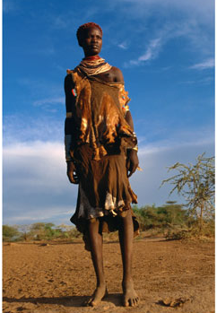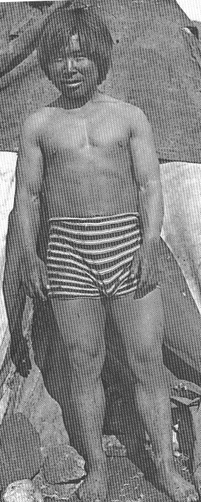

Ectomorph -
- has a high SA:Vol
- don’t store fat reducing insulating effect
- greater heat loss in hot environment
- reduces energy requirements to maintain body temp

Endomorph
- has low SA:Vol
- have ability to store fat under the skin increasing insulation layer
- reduces heat loss in a cold environment
- reduce energy intake for people living in resource poor environments

(b) Few populations today have totally nomadic or hunter-gather lifestyles.

Explain why these lifestyles can not be maintained in the modern world. Give examples to support your answer.
(7 marks)
Reasons | Examples
require a large area over which to move during the year | few large areas available to seasonal use
need access to fertile areas to gather food | most fertile areas have been taken for modern agriculture  access is denied those who don’t have legal title to the land
access to water/variety of areas/traditional areas denied due to urban development | camping only in designated areas; loss of water holes due to desertification
traditional nomadic routes are in different countries with different rules about entry and exit | patrols of countries borders to reduce movement of rebels etc eg Sudan and central Africa
desertification of traditional routes | waterholes in Sahara are drying up making survival problematic
many now want education for their children and some level of health care so are required to stay in one place | Aborigines in central Aust

(c) Explain how cultural development before people began domesticating of animals and cultivating of crops (development of civilisation) may have influenced human population size and distribution.
(7 marks)
Cultural development | Influence on population size and distribution
tools | increased population  - increased supply of food  - protection from predators  - could hunt a greater variety of animals
clothing | increased distribution  - could survive in areas that were previously too cold to occupy at some time during the year.  increased population  - protection against effects of cold weather
shelter | increased distribution  - could live in areas that were too wet or cold or hot  increased population  - protection against effects of cold weather
co-operative hunting | increased population  - could care for those such as older/sick or young
living in community groups | increased population  - specialisation in occupation  - more efficient use of materials/resources

END OF PAPER

ACKNOWLEDGEMENTS

Question 1: http://www.vcaa.vic.edu.au/vce/studies/biology/pastexams/2006/2006biol2-w.pdf

Question 3: http://www.vcaa.vic.edu.au/vce/studies/biology/pastexams/2004biol2.pdf

Question 6: http://www.vcaa.vic.edu.au/vce/studies/biology/pastexams/2003_biol2.pdf

Question 7: http://www.vcaa.vic.edu.au/vce/studies/biology/pastexams/biology22002.pdf

Question 18: http://www.dailymail.co.uk/pages/live/articles/news/news.html?in_article_id=377839&in_page_id=1770

Question 21: http://anthro.palomar.edu/homo/homo_3.htm

Question 25: www.vcaa.vic.edu.au/vce/studies/biology/pastexams/2004biol1.pdf
Published by the Curriculum Council of Western Australia
27 Walters Drive
OSBORNE PARK WA 6017

Questions 33 and 34: www.vcaa.vic.edu.au/vce/studies/biology/pastexams/2004biol1.pdf

Question 36: http://www.nvsd44.bc.ca/sites/pdf/1/1-467-3481.pdf

Question 41:
Figure 1 Source: Barnes, E. (n.d.). Welcome to the Piltdown House web page. Retrieved January, 2006, from http://www.piltdown.org.uk/

Figure 2 http://www.geocities.com/archaeology323/purpose.htm (modified)

Question 42:
Figure 3 From: http://www.capioeye.co.uk/eyeinfo/anatomy/index.html

Question 43
Figure 4 Statistics from: https://www.cia.gov/library/publications/the-world-factbook/print/et.html
Figure 5 From: http://www.population-growth-migration.info/essays/DemographicDividend.html

Question 47: From: Spenceley, M. et all. (2004) Heinemann Queensland Science Project, Biology: a contextual approach. Heinemann Harcourt Education, Melbourne. page 454.

Question 48:
Figure 12 Newton, T. and Joyce, A. (2001) Human Perspectives Book 2 revised 2001. McGaw-Hill p.237
Figure 13: Newton, T. and Joyce, A. (2001) Human Perspectives Book 2 revised 2001. McGaw-Hill p.242
Figure 14: Newton, T. and Joyce, A. (2001) Human Perspectives Book 2 revised 2001. McGaw-Hill p.279

Question 52: (A) From: http://www.allposters.com/-sp/Karo-Woman-with-Typical-Hairstyle-of-Small-Ochre-Coloured-Knots-Murulle-Ethiopia-Posters_i1130603_.htm
(B) From: TEE Human Biology paper 2003

